Regional and Business Studies (20xx) Vol 1x No x, x-xx
Hungarian University of Agriculture and Life Sciences Kaposvár Campus
Kaposvár
doi: xx

Title According to the Rules of Capitalization
Author Author¹, Author Author², Author Author¹,
¹Kaposvár University, H-7400 Kaposvár, Guba Sándor u. 40.
²Corvinus University of Budapest, H-1093 Budapest, Fővám tér 8.
ABSTRACT
Summary of the paper. It briefly describes the topic, the objectives, and results too. Only one paragraph. Minimum 100, maximum 250 words.
Keywords: maximum 5 relevant keywords preferably do not match the words of the title
JEL codes: optional
INTRODUCTION
This template is created for the authors of Regional and Business Studies. The template contains the structure of the article. Please use this template by inserting the parts of the text accordingly. Both the paragraph and character styles are included. The highlighted text in the headers is reserved for the editors. Please do not modify the copyright information either.
The title must be capitalized. There are examples about the rules of capitalization on the website YourDictionary.com (n.d.).
The last name of the authors must be formatted with Small Caps format in Font properties. The Author_last_name character style can be used also.
About JEL codes examples can be found for example on the webpage cran.r-project.org (n.d.)
In the paper, we recommend using the chapter titles listed here primarily, but this may be waived in justified cases.
The chapters in the paper are not numbered. Chapters can be divided into subchapters, using Title2 style for its titles. Within this, another subchapter can be opened with the title in Title 3 format. It is not allowed to break the text into further subchapters.
Subchapter
Subsection of Subchapter
No ident after the title in the first line of the chapters and subchapters (use the Normal_text_after_title style), but use ident in any other paragraphs.
Parts of the paper should be formatted with predefined styles, the names of the styles refer to the text. Paragraph styles used:
- Title of article: Title;
- Names of authors: Author;
- Work place and address: Affiliation;
- Title of Abstract: Abstract_title;
- Abstract text: Abstract;
- Keywords: Normal_text;
- JEL codes: Normal_text;
- Title of chapters: Chapter_title;
- Reference list: Reference_list;
- Title of Figures and Tables: Fig_Tab_title;
- Source of Figures and Tables: Source
- Bulleted list: Bullets;
- Numbered list: Numbering.
Before the first line of the list and after the last line of it use 3 pt spacing. In the case of a multi-level list, the left indent of the subordinate list elements must be increased by 0.5 cm, respectively. The rules of numbered list formatting as same as bulleted list.
- First,
- Second.
Highlights that are important to the author should be formatted in italics in the text.
MATERIALS AND METHODS
APA 7th edition must be used in in-text citations. There are descriptions of APA7th edition on many pages on the Internet (e.g., scribbr.com, n. d. a), also a link generator will help citations on scribbr.com (n.d. b) Internet sources must be referred in-text as shown in the previous sentence.
The in-text citation of APA style consists of the author’s last name and the year of publication (Smith, 2020). In the case of a literal quote, the page number must also be indicated (Smith, 2020, p. 170). It is possible to enter the author's name outside the parentheses, for example: According to Smith (2020) we …
In case of two authors, a & sign must be placed between the names (Smith & Taylor, 2021), while for 3 or more authors, the name of the first author is followed by “et al.” (Smith et al., 2020).
If a section has more than one reference, they must be separated by semicolons (Smith, 2020; Taylor, 2020; Smith et al. 2021).
The names of the authors must be formatted in italics.
All items listed in the reference list have to be found as in-text references. All detailed information of the in-text references has to be indicated on the reference list.
The References should list the sources cited in ascending order in alphabetical order. If the referred literature has a doi number, it must be indicated. An example of a reference list is shown in Figure 1.
Figures and tables should also be referred to in-text. This allows to place the figure or table further away from reference, helping to create a decent format by avoiding parts that are left blank. References can be added within or outside parentheses (Figure 1) or ‘The Table 1 shows …’ References may be formatted with italic similar to the literature sources.
If it is not the author's own work, the source of the tables and images must also be provided. If the source is included in the Reference list, it must be marked in the same way as the in-text references, including the page number a s well (Source: Smith, 2020, p. 170).
If the source of the referenced image is the Internet, then the reference method already presented should be used and a hyperlink to the image should be given in the reference list, so that the reader of the article can jump to the source immediately, see Figure 1. If the author uses a data set to create a table or chart, the source should be as following: Source: Based on Eurostat, 2020.
Figure 1: Some examples of APA 7 reference style
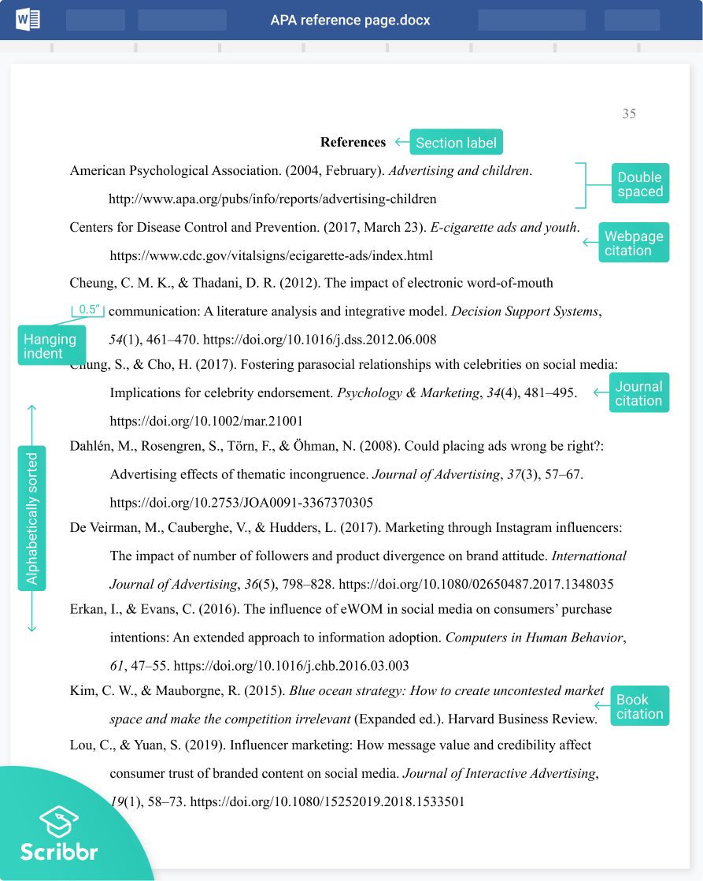
The figure shows the format of the recommended APA reference list for different sources.
Source: scribbr.com (n.d. c)
The titles of the figures and tables do not need to be capitalized.
An example of the format of the tables is shown in Table 1 and Table 2. Table 1 contains text data, while Table 2 contains numbers. In the columns containing numbers, the decimal points should be one below the other. In numbers use the point as a decimal in the entire paper.
Table 1: All 27 applied elements
All elements
The organization & market | Leadership & Motivation | Quality and internal processes
The company as it used to be | Myself today | HR
The company today | My direct manager | Logistics/Warehouse
The company in 2.5 years | The company without leadership | Sales Department
The ideal company | Ideal leadership | Product management / purchase
A negative company | Leadership culture | IT
The companies brand | Myself as a manager | Marketing
The market in the future | CEO 1 | Employee culture
An unpleasant competitor | CEO 2 | Quality principle
A meaningful company | A highly motivated person | An efficient process
Source: Bundtzen (2019, p. 4.)
Table 2: Coordinates of the main CS relevant element
No | Element | x | y | z
1 | The company today | -7.59 | 20.68 | 12.30
2 | Ideal leadership | 27.92 | -8.85 | 1.02
3 | A meaningful company | 28.22 | -9.00 | 0.08
4 | Leadership culture | 1.71 | 17.47 | 10.32
5 | Employee culture | -5.80 | 10.96 | 11.73
6 | The market in the future | 21.80 | -9.81 | -0.89
7 | A negative company | -37.01 | 8.34 | -3.86
8 | The companies brand | 11.60 | 8.67 | 9.81
9 | The ideal company | 32.08 | -9.99 | 0.80
Source: Bundtzen (2019, p. 5.)

Equations should also be followed by reference numbers in parenthesis. Within the text, the reference number should be used to indicate the equation. For example: The formula (1) describes …; According to equation (1) …
y = ax² + bx + c (1)
RESULTS AND DISCUSSION
CONCLUSIONS
ACKNOWLEDGEMENT
If necessary.
REFERENCES
Bundtzen, H. . (2019). Assessing Corporate Sustainability with Repertory Grid Based Personal Construct Psychology. Regional and Business Studies, 11(2), 1–12. https://doi.org/10.33568/rbs.2406
cran.r-project.org (n.d.) JEL Classification Codes.
https://cran.r-project.org/web/classifications/JEL.html
scribbr.com (n.d., a). How to cite sources in APA format. https://www.scribbr.com/category/apa-style/
scribbr.com (n.d., b). Create accurate APA citations for free. https://www.scribbr.com/apa-citation-generator/
scribbr.com (n.d., c). APA reference page. https://www.scribbr.co.uk/wp-content/uploads/2019/02/apa-reference-page-7th-ed.png?_ga=2.53458600.1652905297.1620294760-1306331516.1616855722
YourDictionary.com (n.d.) Common Title Capitalization Rules. https://grammar.yourdictionary.com/capitalization/rules-for-capitalization-in-titles.html
Corresponding author:
Firstname Lastname
Workplace
Address, e.g. H-7400 Kaposvár, Guba Sándor u. 40.
Tel.: optional
e-mail: firstname.lastname@mail.hu
© Copyright 2020 by the authors.
This is an open access article under the terms and conditions of the
Creative Commons attribution (CC-BY-NC-ND) license 4.0.

